***Domestic Violence Awareness***

***Do you know what domestic violence is? Total: 307***

**Yes**: 296

**No**: 11

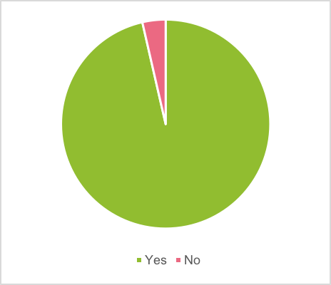

***What of the following is a form of Domestic Violence? Total: 301***

1. **Stalking**: 0
2. **Physical Abuse:** 68
3. **Verbal Abuse**: 6
4. **Emotional Abuse**:1
5. **All of the above**: 226 [CORRECT ANSWER]

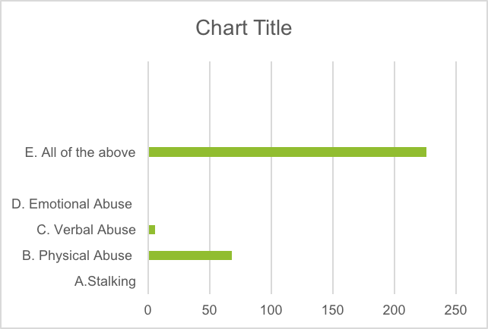

***What age group of women is most likely to experience Domestic Violence? Total: 311***

1. **6 to 10:** 4
2. **11 to 17:** 78
3. **18 to 34:** 210 [CORRECT ANSWER]
4. **35 to 50:** 19

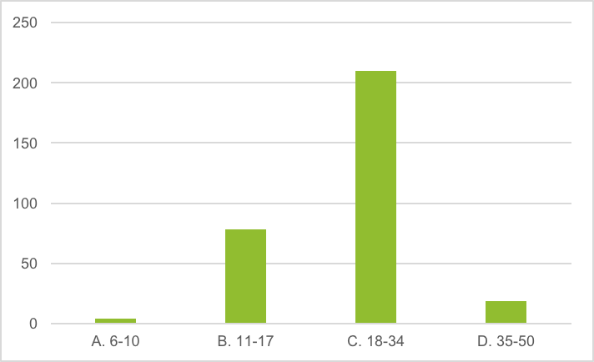

***Do you know anyone who has experienced Domestic Violence? Total: 317***

**Yes**: 132

**No**: 185

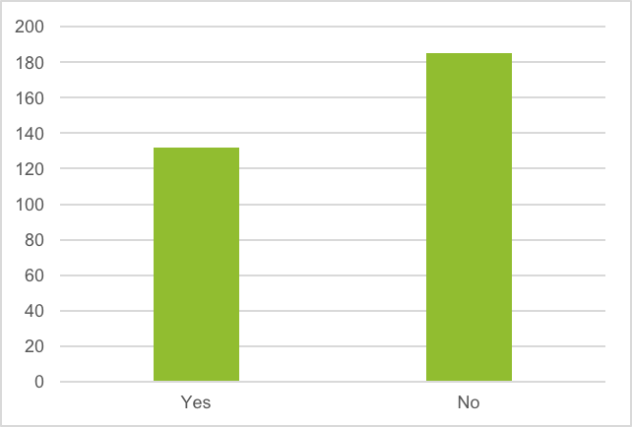

***If you or someone else is experiencing Domestic Violence, would you know where to go?***

***Total***: 289

**Yes**: 229

**No**: 52

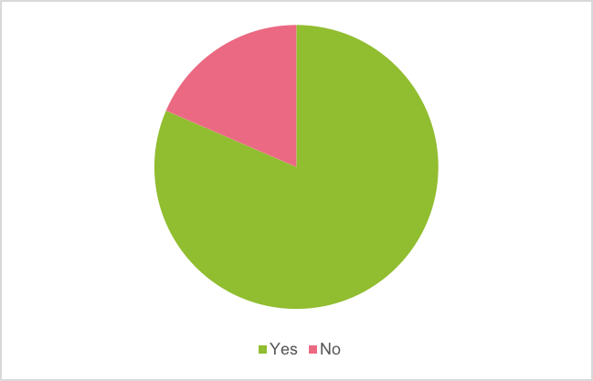

Summary:

A total of 317 domestic violence (DV) awareness surveys were completed during the Teen Health Educator’s tabling event in October. The majority of people who took the survey answered that they knew what domestic violence was (96%). Many students also knew someone else who had experienced domestic violence (42%). To bring awareness you can educate your friends on this matter. Although students checked off that they knew in general what DV was, many did not know about the specific forms of domestic violence. 23% of students answered that physical abuse is the only form of domestic violence. Additionally, even though the question asking about the specific forms of DV clearly instructed the participant to choose only one answer, a number of students chose more than one—leaving us to throw the question out several times. This shows a sense of confusion and a lack of knowledge on what exactly Domestic Violence is. Many students also said they knew where to go if they or someone they knew were experiencing domestic violence. Still, a lot of people did not know. The majority of students also believed that the age of women most likely to experience domestic violence was 18 to 34, which is correct. Although some students were right, others had false information that needed to be corrected. Finally, 23% of students stated that they did not know where to go for help if needed. The data from our surveys show a lack of education and a real need for more awareness and resources.

Winner Evu

Teen Health Educator

Sophomore/CHS